U.S. Scientists See Long Fight Against Ebola
By DENISE GRADYSEPT. 12, 2014 NYT.
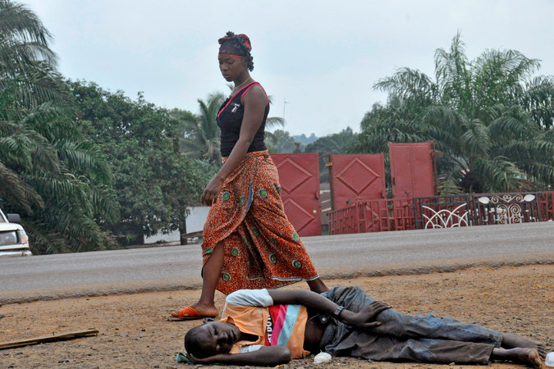
A woman in Monrovia, Liberia, passed a man believed to be infected with Ebola. Researchers say it could take 12 to 18 months to bring the epidemic under control. Credit Abbas Dulleh/Associated Press
The deadly Ebola outbreak sweeping across three countries in West Africa is likely to last 12 to 18 months more, much longer than anticipated, and could infect hundreds of thousands of people before it is brought under control, say scientists mapping its spread for the federal government.
“We hope we’re wrong,” said Bryan Lewis, an epidemiologist at the Virginia Bioinformatics Institute at Virginia Tech.
Both the time the model says it will take to control the epidemic and the number of cases it forecasts far exceed estimates by the World Health Organization, which said last month that it hoped to control the outbreak within nine months and predicted 20,000 total cases by that time. The organization is sticking by its estimates, a W.H.O. spokesman said Friday.

Related Coverage

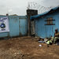

Ebola Outpaces Global Response, W.H.O. SaysSEPT. 12, 2014

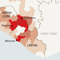

Liberian President Pleads With Obama for Assistance in Combating EbolaSEPT. 12, 2014

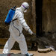

Cuts at W.H.O. Hurt Response to Ebola CrisisSEPT. 3, 2014

graphic

What You Need to Know About the Ebola OutbreakJULY 31, 2014

But researchers at various universities say that at the virus’s present rate of growth, there could easily be close to 20,000 cases in one month, not in nine. Some of the United States’ leading epidemiologists, with long experience in tracking diseases such as influenza, have been creating computer models of the Ebola epidemic at the request of the National Institutes of Health and the Defense Department.
Photo
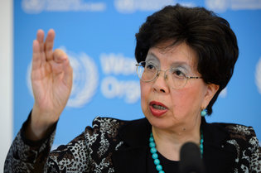
Dr. Margaret Chan, director general of the W.H.O., which has stood by its lower projections of the toll of the Ebola outbreak. Credit Martial Trezzini/KEYSTONE, via Associated Press
The Centers for Disease Control and Prevention declined to comment on the projections. A spokesman, Tom Skinner, said the agency was doing its own modeling and hoped to publish the results soon. But the C.D.C. director, Dr. Thomas R. Frieden, has warned repeatedly that the epidemic is worsening, and on Sept. 2 described it as “spiraling out of control.”
While previous outbreaks have been largely confined to rural areas, the current epidemic, the largest ever, has reached densely populated, impoverished cities — including Monrovia, the capital of Liberia — gravely complicating efforts to control the spread of the disease. Alessandro Vespignani, a professor of computational sciences at Northeastern University who has been involved in the computer modeling of Ebola’s spread, said that if the case count reaches hundreds of thousands, “there will be little we can do.”
What worries public health officials most is that the epidemic has begun to grow exponentially in Liberia. In the most recent week reported, Liberia had nearly 400 new cases, almost double the number reported the week before. Another grave concern, the W.H.O. said, is “evidence of substantial underreporting of cases and deaths.” The organization reported on Friday that the number of Ebola cases as of Sept. 7 was 4,366, including 2,218 deaths.
“There has been no indication of any downturn in the epidemic in the three countries that have widespread and intense transmission,” it said, referring to Guinea, Liberia and Sierra Leone.
The scientists who produced the models cautioned that their dire predictions were based on the virus’s current uncontrolled spread and said the picture could improve if public health efforts started to work. Because conditions could change, for better or for worse, the researchers also warned that their forecasts became shakier the farther into the future they went.
Continue reading the main story

Predicting Ebola’s Future Toll
Assuming current infection rates continue, a new model estimates there could be 20,000 Ebola cases by mid-October. The model’s estimate would nearly triple under deteriorating conditions and an increasing infection rate.
Dr. Lewis, the Virginia Tech epidemiologist, said that a group of scientists collaborating on Ebola modeling as part of an N.I.H.-sponsored project called Midas, short for Models of Infectious Disease Agent Study, had come to a consensus on the projected 12- to 18-month duration and very high case count.
Another Midas participant, Jeffrey L. Shaman, an associate professor of environmental health sciences at the Columbia University Mailman School of Public Health, agreed.
“Ebola has a simple trajectory because it’s growing exponentially,” Dr. Shaman said.
Lone Simonsen, a research professor of global health at George Washington University who was not involved in the modeling, said the W.H.O. estimates seemed conservative and the higher projections more reasonable.
“The final death toll may be far higher than any of those estimates unless an effective vaccine or therapy becomes available on a large scale or many more hospital beds are supplied,” she said in an email.
Continue reading the main story Video
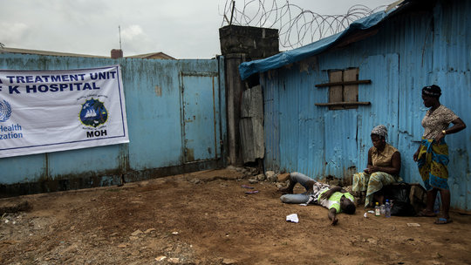

Play Video|3:47

Dying of Ebola at the Hospital Door

Dying of Ebola at the Hospital Door
Monrovia, the Liberian capital, is facing a widespread Ebola epidemic, and as the number of infected grows faster than hospital capacity, some patients wait outside near death.
Video Credit By Ben C. Solomon on Publish Date September 11, 2014.
Dr. Vespignani said that the W.H.O. figures would be reasonable if there were an effective campaign to stop the epidemic now, but that there is not.
The modeling estimates are based on the observed growth rate of cases and on factors like how many people each patient infects. The researchers use the past data to make projections. They can test their methods by, for instance, taking the figures from June, plugging them into the model to predict the number of cases in July, and then comparing the results with what actually happened in July.
Dr. Shaman’s research team created a model that estimated the number of cases through Oct. 12, with different predictions based on whether control of the epidemic stays about the same, improves or gets worse. If control stays the same, according to the model, the case count by Oct. 12 will be 18,406. If control improves, it will be 7,861. If control worsens, it will soar to 54,895.
Before this epidemic, the largest Ebola outbreak was in Uganda from 2000 to 2001, and it involved only 425 cases. Scientists say the current epidemic surged out of control because it began near the borders of three countries where people traveled a lot, and they carried the disease to densely populated city slums. In addition, the weak health systems in these poor countries were not equipped to handle the disease, and much of the international response has been slow and disorganized.
Continue reading the main story Write A Comment
But questions have also been raised about whether there could be something different about this strain of Ebola that makes it more contagious than previous ones.
Researchers are doubtful, but Thomas W. Geisbert, an Ebola expert at the University of Texas Medical Branch in Galveston, said it was important to keep an open mind about the possibility. During vaccine tests expected to start next month in monkeys, he said, he and his colleagues will monitor infected animals to see if they develop unusually high virus levels early in the disease that might amplify its infectiousness.
Some scientists have also suggested that as the outbreak continues and the virus spreads from person to person, it will have more opportunities to mutate and perhaps become even more dangerous or contagious. But Stuart T. Nichol, chief of the C.D.C.’s Viral Special Pathogens Branch, said that so far, researchers monitoring the mutations had seen no such changes.

Predicting Ebola’s Future Toll

Assuming current infection rates continue, a new model estimates there could be 20,000 Ebola cases by mid-October. The model’s estimate would nearly triple under deteriorating conditions and an increasing infection rate.

